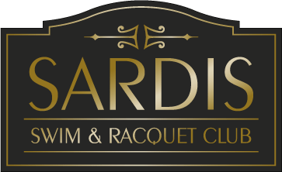 2023 Sardis Operating Hours

Date | Pool Hours | Concession Hours
May 13th | 11–6pm | 11–6pm
May 14th | 12-6pm | 12-6pm
May 15th – 19th | 1:30-3:30pm | 4-6pm
May 20th | 11-8pm | 11-7pm
May 21st | 12-8pm | 12-7pm
May 22nd -26th | 1:30-3:30pm & Friday 6- 8:00pm | 4 -6pm (Friday 4-7pm)
May 27th | 11 -8pm | 11 -7pm
May 28th | 12- 8pm | 11- 7pm
May 29th | 11-7pm Memorial Day | 12-7pm
May 30th – June 2nd | 11-3:30pm & Friday 6 -9:00pm) | 4-6pm
June 3rd | 11- 10pm | 11-8pm
June 4th | 12 – 9pm | 12-8pm
June 5th -9th | 11 -3:30pm & 6:00 -8pm Friday 9pm | 4-7pm
June 10th | 11-10pm | 11 -8pm
June 11th | 12-9pm | 12- 8pm
June | Regular season hours begin (see below) | See below
Regular Season Hours
June 10th^{th} – August 19th | 11-9pm Mon-Sat (Fri & Sat til  10pm) Sun 12-9pm | 11-7pm Mon –Sat (Fri til 8pm)  Sun 12 -7pm
August 20th –Sept 10th | 3-7pm Mon-Thur (Fri til 8pm)  Sat 11- 8pm Sun 12-7pm | 3-6pm Mon- Thur (Fri til 7pm)  Sat 11-7pm  Sun 12-6pm
Special Dates:
May 29th ( Memorial Day) | 11 – 7pm | 11-7pm
July 4th | 11 – 7pm | 11-7pm
September 6th (Labor Day) | 11-7pm | 11-6pm
Exceptions to the above pool hours
Home Swim and dive meets, Pool will close at 4:00 for swim meets and 4:30 for dive meets
*Pool may be open weekends after September 10th – weather permitting and staff availability

